**The following points highlight the top six theories regarding the origin of metazoa. The theories are: 1. Syncytial-Ciliate Theory 2. Colonial Flagellate Theory 3. Colonial Blastea and Planula Theories 4. Gastraea Theory 5. Monophyletic Origin of Metazoans 6. Polyphyletic Origin of Metazoans.**

**1. Syncytial-Ciliate Theory:**

The origin of metazoans probably took place through the growth, nuclear division and cellularisation of a single protozoan. Depending on this idea, Hadzi (1953, 1963) proposed the syncytial-ciliate theory. His version supported by Steinbock (1958, 1963) and Hanson (1958, 1963, 1977). Hadzi proposed that the first metazoan evolved from a primitive multinucleated protozoan of a ciliate type.

The multinucleate ciliate represented either Paramoecium or Opalina. These animals are syncytial in nature, i.e., the nuclear division takes place without cytoplasmic division. In course of evolution the multinucleated cytoplasm developed boundary cell membranes between the nuclei and in course of time metazoans have developed from these ciliated protozoans (Fig. 22.2).

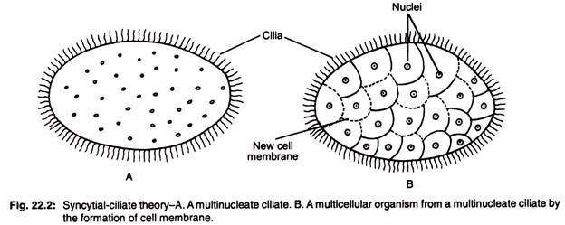

A bilateral ancestor could give rise to the acoel turbellarians which is devoid of gut. But Hadzi believed that midgut tissue of acoels is probably syncytial in nature and it may be believed that acoels would be the ancestral stock from which all other metazoans, such as Mollusca, Annelida, Arthropoda, Echinodermata and Chordata, have originated except poriferans which could have originated from flagellated protozoans in a separate line.

It may be assumed that flatworms and spiralian protostomes may have derived from opalinids because they belong to multiciliated metazoans but sponges and cnidarians are monociliated, so could not develop from the multiciliated acoel ancestor.

Spiralian protostomes include molluscs, annelids and arthropods and they are called for the spiral cleavage during embryonic development.

#### 2. Colonial Flagellate Theory:

This theory was proposed by a German scientist Haeckel (1874, 1875) and supported by Lankester (1873, 1877), Metschnikoff (1886) and Hyman (1940).

Morphological data indicate to the understanding of the transitional stages of the Metazoa suggest a colpnial origin of Metazoa. The recent popularity of colonial theory was due to the acceptability of Hyman who updated the theory. According to this theory, the most primitive metazoan was originated from colonial flagellated protozoa.

Haeckel stated that the colonial ancestor of Metazoa was spherical, hollow, volvox-like colonial flagellate. Lankester proposed that the ancestral colonial protozoa were solid, flagellated protozoan-like animal (e.g. Pandorina). Metschnikoff has also stated that the ancestral colonial choanaflagellate was solid and resembles the existing Proterospongia.

The outer layer of the colonial Proterospongia possesses collared cells help in locomotion and the inner layer is filled with amoeboid cells. When the flagella and the collares of the Proterospongia are lost, these cells move into the central area like amoeboid cells (Fig. 22.3).

#### C:\Users\Administrator\Desktop\clip_image004_thumb-178.jpg

#### 3. Colonial Blastea and Planula Theories:

It is presumed that the primitive metazoans first originated from a spherical, hollow, colonial flagellate (Fig. 22.4).

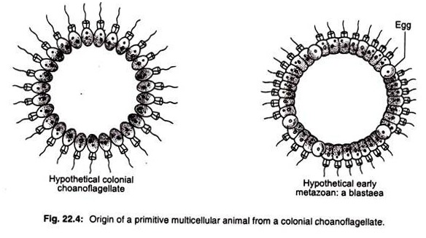

**The evidences in support of this statement are:**

(i) Sperm cells are flagellated in all metazoans, and

ii) In lower metazoans such as sponges, in many cnidarians, the monociliated cells occur within the body.

The cells of the colony bear collar-like structure around a single flagellum and possess anterior-posterior axis and would swim by placing the anterior pole forward. The cells were differentiated into somatic (non-reproductive) and reproductive cells. Haeckel proposed this hypothetical ancestral stage, the blastaea as a first stage in metazoan origins.

Blastea may be compared with the existing blastula stage of the multicellular animals and resemble the present day Volvox colony. The next evolutionary stage is a solid, non-evaginated structure of the archemetazoan which is called parenchymula or planaea (also called planula).

The planula ancestor is represented as a small, ovoid, pelagic animal with radial symmetry containing solid mass of cells and the internal cell mass is to be considered as the migratory cells of the blastula stage.

The planula stage gave rise to cnidarians and ctenophores by separate lines and it is also presumed that in course of evolution, the benthic, bilateral primitive flatworms (e.g., Turbellarian-acoels) have evolved from the sexual planulae.

#### 4. Gastraea Theory:

This theory was proposed in somewhat modified form by Metschnikoff. He proposed a solid double walled cup-like structure, called the gastraea which formed by the invagination of the blastaea at the posterior pole. The gastraea represents the gastrula stage of development in the existing multicellular organisms and proposed as a metazoan ancestor.

The outer layer of the gastraea is called ectoderm and an inner layer is called endoderm. The space which is enclosed by the endoderm is called primitive gut. The gut communicates to the exterior by the mouth (protostome) (Fig. 22.5).

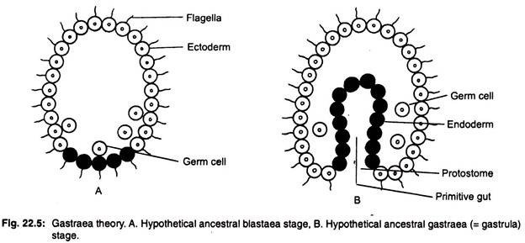

Later on, colonial theories have been made up-to-date by Hand (1963), Ivanov (1968) and Reisinger (1970), etc. Greenberg (1959) has pointed out that planula larva is seen not only in many cnidarians but also in a few sponges and at least in a single ctenophore.

#### 5. Monophyletic Origin of Metazoans:

Muller (2001) reported that the adhesion molecules are found in the sponges and also present in the major metazoan phyla. So it may be considered that all metazoans originated from a single common ancestor who may be called Urmetazoa.

#### 6. Polyphyletic Origin of Metazoans:

**Recent molecular studies based on rDNA have suggested that the origins of Metazoans are polyphyletic and some of them are described below:**

**(i) Greenberg (1959):**

Greenberg (1959) has stated that metazoans have originated from two ancestors, such as sponges and cnidarians have evolved separately from colonial flagellates and ctenophores and flatworms from the ancestral ciliates.

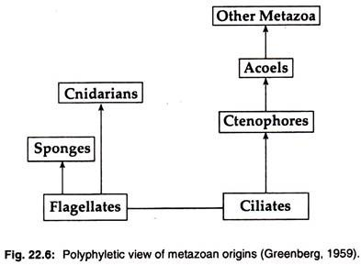

**(ii) Nursall (1962):**

Nursall (1962) has proposed that different multicellular invertebrate phyla have evolved independently from different protists.

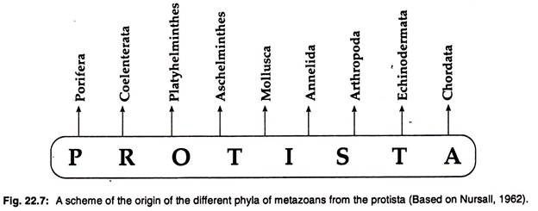

**(iii) Hanson (1977):**

Hanson (1977) advocated that a colonial amoeboid form which is considered as the ancestor of cnidarians, and platyhelminthes is derived from syncytial ciliates.

**(iv) Hanson (1977) and Sleigh (1979):**

Hanson (1977) and Sleigh (1979) have proposed that sponges and cnidarians have evolved separately from flagellated protists and other group-ciliates has origi­nated from flagellated protists and ciliates have given rise to Acoel-platyhelminthes and other metazoan phyla have evolved from Acoel-platyhelminthes.

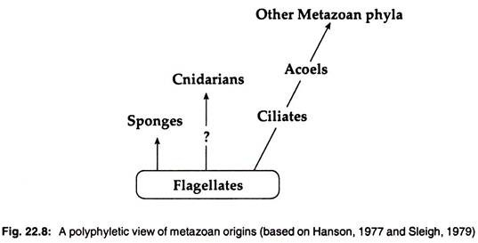

**(v) Valentine (1973):**

Valentine (1973) has created 5 coelomate super-phyla with deuterostomes and Tentaculata (lophophores) being joined by three new groups which split up from the usual protostome assemblage.

**This division is largely based on segmentation and these superphyla are:**

(i) Metameria or Polymeria included annelids and arthropods.

(ii) Amera or Sipunculata included only unsegmented sipunculan worms and

(iii) Mollusca included creeping animals and unsegmented coelom.

Valentine’s scheme is the establishment of superphyla rather than traditional morphological criteria.

**[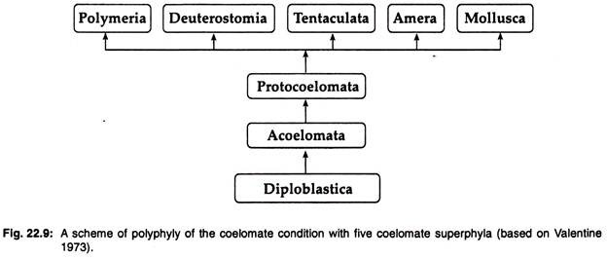](https://cdn.biologydiscussion.com/wp-content/uploads/2016/05/clip_image013-16.jpg)**

**(vi) Anderson (1982):**

Anderson (1982) has stated that Cnidaria and Ctenophora have evolved from choanoflagellates, and deuterostomes and other groups of minor phyla have evolved from different protist groups independently.

**(vii) Nielsen and Norrevang (1985):**

Nielsen and Norrevang (1985) forwarded the trochaea theory in which the pelagic trochophore larva (trochaea) transforms into blastaea and gastraea, to form the ancestor of spiralians, and in turn gives rise to a pelagic tornaea as the ancestor of deuterostomes.